**Queensborough community college**

The city university of New York

**Department of engineer technology**

Date: 9/2/16

Student Name: XIN SHEN

Inspector: Prof. HUIXIN WU

eT 110-introduction to circuit analysis laboratory

lab#2

resistors: power rating, color code & resistance measurements.

potentiometers

**State the “Objectives” of this lab exercise**

* Research the Resistors from the internet
* Resistor color code and how to get the Tolerance, value range for the resistors
* Measure the value of the resistors and use the measurements comparing with the range of the resistor.
* Introduction of Potentiometers and Rheostats
* Internet research: Potentiometer Specifications

**List all “Lab Components” used for this lab**

* Breadboard
* Resistor Color Guide
* Multimeter
* Component resource kit (foam board) Which including a lot of resistors and potentiometers

**Experimental: Part One- Resistors**

**1**

|  |  |
| --- | --- |
| *Tolerance* | *Color* |
| ±1% | brown |
| ±2% | red |
| ±5% | gold |
| ±10% | silver |

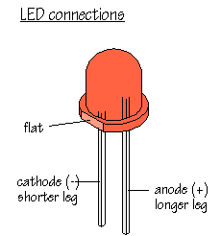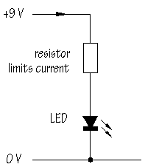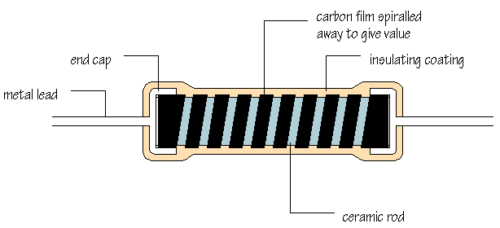

**2-8.**

[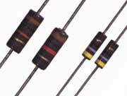](http://www.ohmite.com/cat/res_od_of_oa.pdf)Features

• Molded insulation for high dielectric strength

• Rugged construction

• High surge capabilities

• Comparable to “Mil” RC07, RC20, and RC32 types

• OD/OF Series available in E24 values

• OA Series available in E12 values

**9-12**

|  |  |
| --- | --- |
| **Digi-Key Part Number** | **Unit Price USD** |
| [OD22GJE-ND](http://www.digikey.com/product-detail/en/ohmite/OD22GJE/OD22GJE-ND/823717) | 0.70000 |
| [RC14JT2R20-ND](http://www.digikey.com/product-detail/en/stackpole-electronics-inc/RC14JT2R20/RC14JT2R20-ND/1744938) | 0.08775 |
| [CBT25J2R2-ND](http://www.digikey.com/product-detail/en/te-connectivity-amp-connectors/CBT25J2R2/CBT25J2R2-ND/2381672) | 0.09819 |
| [RC14JB2R20-ND](http://www.digikey.com/product-detail/en/stackpole-electronics-inc/RC14JB2R20/RC14JB2R20-ND/1744937) | 0.10400 |

**13-18**

| **Specification** | **Value** |
| --- | --- |
| Resistance (ohm) | 1000 |
| Power (Watts) | 0.25 |
| Tolerance (%) | 5 |
| Package | AXIAL LEADED |
| Product Type | RESISTOR |
| Size | STANDARD |
| Packing Method | CUT TAPE |
| Mounting Feature | THROUGH HOLE |
| Resistor Type | CARBON FILM |

**Part2- Resistor Color Code**

**Table 2.4**

|  |  |  |  |  |  |  |
| --- | --- | --- | --- | --- | --- | --- |
| **Color Bands** | **Nominal Value** | **Tolerance** | **Lower**  **Value** | **Upper Value** | **Measured Value** | **Is the measured value between the range? (yes/no)** |
| Red, Red, Black, Gold | 22Ω | ±5% | 20.5Ω | 23.5Ω | 22.8Ω | Yes |
| Brown, Red, Brown, Gold | 120Ω | ±5% | 114Ω | 126Ω | 119.0Ω | Yes |
| Red, Violet, Red, Gold | 2.7kΩ | ±5% | 2.565kΩ | 2.835kΩ | 2.66kΩ | Yes |
| Brown, Green, Orange, Gold | 15kΩ | ±5% | 14.25kΩ | 15.75kΩ | 14.81kΩ | Yes |
| Red,Yellow,.Yellow, Gold | 240kΩ | ±5% | 228kΩ | 252kΩ | 236kΩ | Yes |

**Table 2.5**

|  |  |  |
| --- | --- | --- |
| **Points** | **Predicted Resistance Value** | **Measured Resistance Value(include unit)** |
| **A to B** | 470Ω | 467Ω |
| **A to C** |  | 794 Ω |
| **C to A** | 800Ω | 795 Ω |
| **F to C** |  | 277 Ω |
| **F to A** |  | 1070 Ω |
| **B to D** |  | 547 Ω |
| **C to E** | 267Ω | 276Ω |
| **F to E** |  | 11.4Ω |

**Part 5 Internet Research: Potentiometer Specifications**

|  |
| --- |
| **Electrical Specifications** |

*Potentiometer Specifications*

|  |  |
| --- | --- |
| **Resistance Range** | 100 ohms to 5 Megohms - Linear Taper 150 ohms to 1 Megohms - Logarithmic Taper |
| **Resistance Tolerance** | +/-10% or +/-20% |
| **Resistance Taper** | Linear, Logarithmic, Reverse Logarithmic; Other tapers by special order |
| **Power Rating** | 1 Watt @ 70°C; Derate to 0 Watt @ 120°C |
| **Insulation Resistance** | Dry: 10K Megohm; Wet: 100K Megohm |
| **Dielectric Strength** | Sea Level - 900 V RMS |
| **Operating Voltage** | 500 V, subject to power rating |

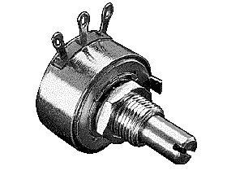

|  |
| --- |
|  |

*25k Allen-Bradley Potentiometer*

* 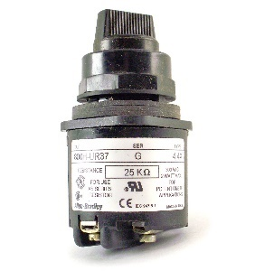Type 4,4X
* 25K Ω
* 300VAC
* 2 Watt Max
* Manufactured by: Allen Bradley
* Part #: 800H-UR37

**Questions**

1. The linear potentiometer has equal resistance value on each side when you turn the pots half way. On the other hand, the audio taper doesn’t have the equal resistance value on each side. In addition, the audio taper can be heard by the human ear. So the audio taper pots are normally used for volume controls and the linear taper pots are used for balance controls.
2. With a linear taper, if you turn the pots halfway, the resistance measured on each side will be equal. With audio tapes, that is not true; the resistance follows a logarithmic evolution. So when we use the ohmmeter to measure half the total resistance if the wiper arm is in the middle, it is the linear taper, otherwise, it is the audio tapes.
3. A rheostat is simply a variable resistance used to control power to a load and you are correct about the wiring. Only the wiper and one other terminal are used. A potentiometer uses all three terminals, enabling a variable voltage or signal to be tapped off from the wiper.
4. The resistor’s color code was Brown Black Brown Sliver.

The nominal value was 100Ω and the tolerance was ±10%. Thus,the resistor range was from 90Ω to 110Ω. However, the measurement was 89Ω which was lower than the lower value 90Ω, so the resistor was not within specs.

1. The resistor had a yellow band on right. It indicated the reliability of the resistor in % over 1000 hours of operation. It told us how many resistors out of 100 would change their values to fall outside the allowed tolerance range after 1000 hours of operation.

So as the yellow band was 1/100,000. It meant after 1000 hours of operation, one of the 100,000 resistors would fall outside the allowed tolerance range.

**Conclusion**

In lab #2, I got a basic knowledge about the resistor. The resistor is the specific amount of resistance into electric circuits. When you work with the resistor you need classify the power rating, resistance value, the amount of allowed tolerance and the type of materials should be. The power rating indicates how hot the resistor can get before burned. It has a positive ratio with the physical size. In addition, in the lab, I learned how to use the color code to calculate a resistor nominal value, allowed tolerance, and the range of the resistor value. Furthermore, I studied the way operating a multimeter to measure the resistor value. After that, I was able to determine the resistor was whether within specs. What’s more? We also were introducing the potentiometer. There are 2 kinds of the potentiometer. One is the linear taper pots and the other is the audio taper pots. Audio taper pots can be heard by human ear so they often use for the volume controls and resistance for them would not be equal when turning them to half way. On the other hand, the linear taper pots couldn’t be heard by human ear so they are used to be the balance controls and resistance would be equal on both sides when turning them to half way. Also, the rheostat is a special potentiometer. It only uses the power controls to make the resistance variable. Basically, the rheostat is using one of the terminal or two end terminals to change the resistance.